How to compile the input file generator
The input file generator is an application to create input files for WinobjVR. It was originally created by Courtney Greer and was updated by Adam Braly. The application was written in javascript/html and uses MongoDB to store previously created input files.

Required software (in this order)
(1) Node.js - Node.js is an open-source, cross-platform, JavaScript runtime environment that executes JavaScript code outside of a browser. Download link
NPM - A package manager for the JavaScript programming language. It comes with Node.js
(2) Electron – An open-source framework developed and maintained by GitHub. Electron allows for the development of desktop GUI applications using web technologies: It combines the Chromium rendering engine and the Node.js runtime.
To install – open a command prompt as admin and type “npm install electron -g”
(3) Electron-packager - A command line tool and Node.js library that bundles Electron-based application source code with a renamed Electron executable and supporting files into folders ready for distribution
To install - open a command prompt as admin and type “npm install electron-packager -g”
(4) An IDE to open and edit the javascript and html files. Adam used JetBrains webstorm (free for 30 days), or you could use Visual Studio Code (VSCode) which is free.

Running the input file generator as is
Unzip the contents of the file to “C:\file gen”. The folder structure will look like this initially.
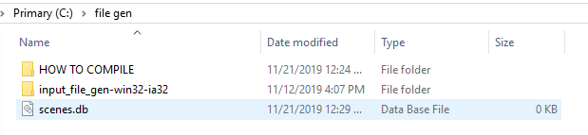
HOW TO COMPILE - contains the current document you are reading.
Scenes.db - contains the trials that have been previously created.
Input_file_gen-win32-ia32 - a folder that contains the following
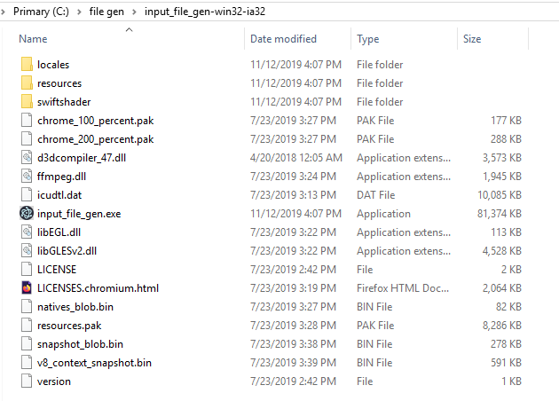

The application itself is input_file_gen.exe. Do not move this file from this folder. You can create a shortcut to this application by right clicking the file and Send To -> Desktop.
**Important**
If you only want to run the application AS-IS, then your folder structure should look like this
And you will run the executable from C:\file gen\input_file_gen-win32-ia32\input_file_gen.exe

If you want to make changes to the code and compile, you must follow the directions in the next section.

Reorganizing the folder structure
We first need to reorganize the folder structure. By default, the source code is included in the folder input_file_gen-win32-ia32 (C:\file gen\input_file_gen-win32-ia32\resources\app)
We need to extract this folder first.
Navigate to C:\file gen\input_file_gen-win32-ia32\resources\app, you should see the following
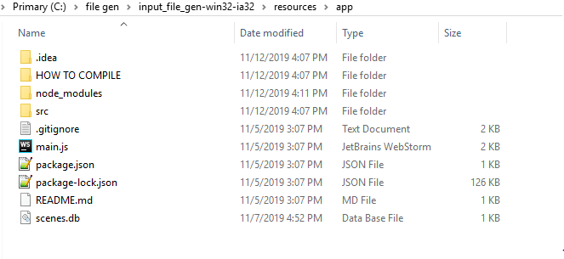
Highlight everything and right click -> copy.
Navigate to C:\file gen, and paste. Replace any duplicate files. You should see the following
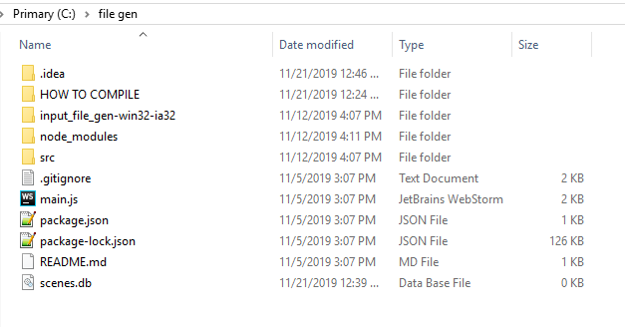

Next, delete the folder input_file_gen-win32-ia32. You should see the following
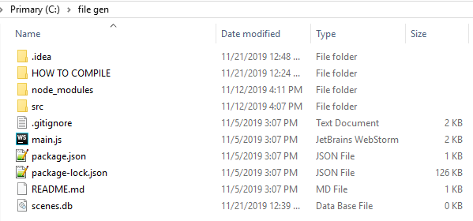
We are now ready to make changes to the code.

Making changes to the code
You will want to open the code in the IDE you have chosen (from step 4 above) and make changes to the code.
How to open with JetBrains Webstorm
Open Webstorm.
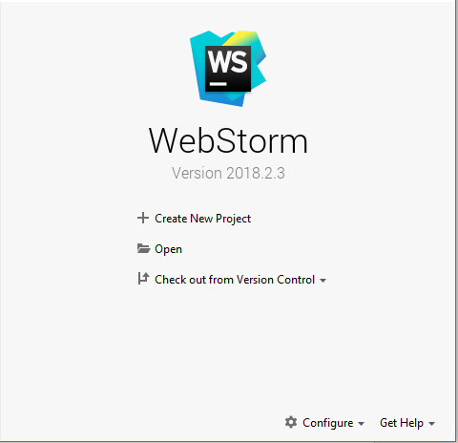
Choose Open
Select the folder C:\file gen and continue. It will look like this
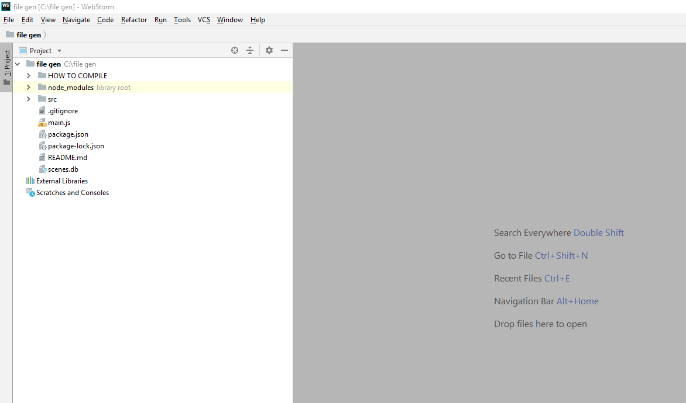

Expand the src folder by clicking the arrow, and then expand the html and js folders. You will see the html and js files to edit.
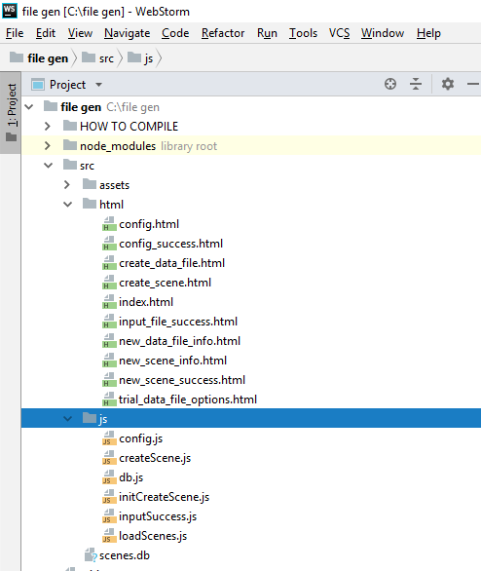
Make your changes to the code. **Remember that this is an HTML/JS project. If you wish to add something visual to the screen, you must edit the HTML file associated with the page you wish to edit. If you need to pass variables to the JS code, this is done with jQuery #id selectors. It is highly recommended that for the person making changes to have at least an intermediate understanding of js/html/jquery before attempting to edit.**

Save all changes. File -> Save all.

Compiling the code to an EXE
Make sure you have saved all changes to the to the files you have modified. File -> Save all.

Open a command prompt and navigate to C:\file gen – cd C:\file gen
The command to compile the code is below:
electron-packager "c:\file gen" input_file_gen --platform=win32 --arch=ia32
This is what you should see upon successful compilation
Now the folder will look like this
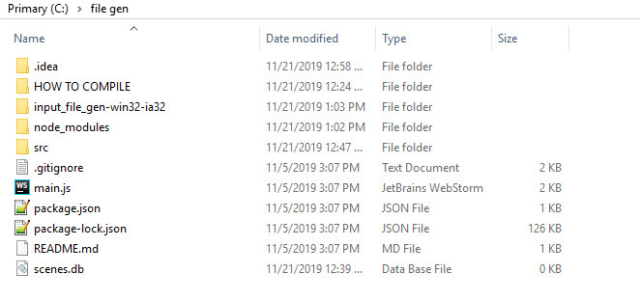
Run the application from C:\file gen\input_file_gen-win32-ia32\input_file_gen.exe and test your changes.
If you get this error
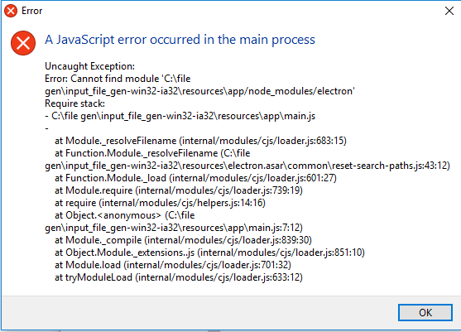

Then do the following: Navigate to C:\file gen\
Copy the folder named “node_modules”
Navigate to C:\file gen\input_file_gen-win32-ia32\resources\app
And paste the folder “node_modules”, overwriting duplicate files.
Note** There is also a copy in C:\file gen\HOW TO COMPILE\node_modules backup in case the former does not work.

Now go back to C:\file gen\input_file_gen-win32-ia32 and try to run input_file_gen.exe.

You should see the following
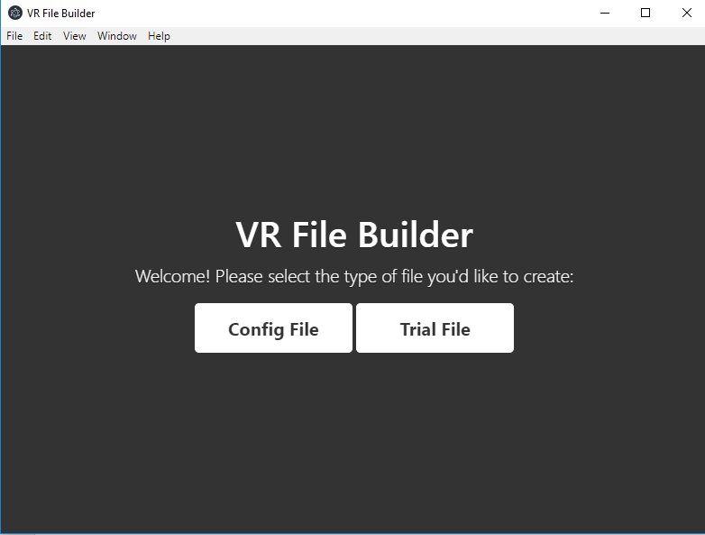

**If you are need to make more changes, make the changes in webstorm. Before you compile again from the command line you need to delete the folder “input_file_gen-win32-ia32” or you can force electron-packager to overwrite with “ - - overwrite” appended to the compile line (untested). Then follow the steps above to recompile.

**If you are satisfied with your changes you can delete everything except for:
HOW TO COMPILE, input_file_gen-win32-ia32, scenes.db
OR, you can leave the folder as it is for later.
Note: files created with this generator are stored in scenes.db and can be added to future input files

